Econ 4420 International Fiance

Steven Beckman

Shuo Liu, Yilin Wang

The Analysis of “Minsky moment”

1. Introduction

The sub-prime financial crisis in 2008 influences aspects of the economy almost in every country, which causing many corporations to go bankrupt, unemployment rate to fall, federal fund rate to rise and price drop in the housing market. Also the Chinese dangerous debt, which is caused by the government using debt to buy the land and manipulating price of the land to take on more debt. In our paper, we will introduce and analyzing the “Minsky moment” and Krugman’s theories which are the Japan’s trap and 2008 housing crisis. Otherwise, we also will talk about the effect of the financial crisis.

1. Theory

What does “Minsky moment” mean? “Minsky moment” is a kind of moment when the credit supply start to dry up. This kind of moment occurs because the long periods of prosperity and increasing value of investments lead to increasing speculation using borrowed money, and the increasing loans in the speculative investment leads to cash flow problems and people have difficulty in paying back the debts.

Krugman also developed his theory in the Japan’s trap.

=,

Allowing a Minsky moment, we can know that a decreasing in the can cause the and rises. In the “Minsky moment”, people are positive to the consumption in the future at the beginning, but when the housing bubble happens, borrower must sell their assets to repay the debt. Also the price of asset is decreasing at the same time, so they have to sell more assets and decrease the consumption. It means decreases and IS shifts left. Thus decreases and IS shifts left until there is no equilibrium and full employment cannot be preserved, and it also called liquid trap. It is also similar with the financial crisis in 2008. The only way to solve this problem is making the public believe that the price in the future will increase.

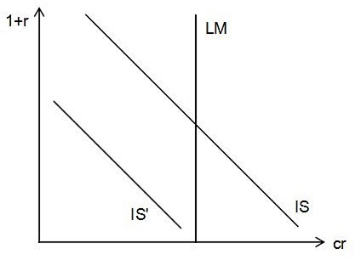

In the Asian crisis, the value of domestic currency is falling, followed by the rising income and export. Also it causes the foreign debt increases which leads to the bankruptcies. How about the financial crisis in 2008? The poverty price in 2008 falls, followed by the rising value of dollar, falling net export and income.

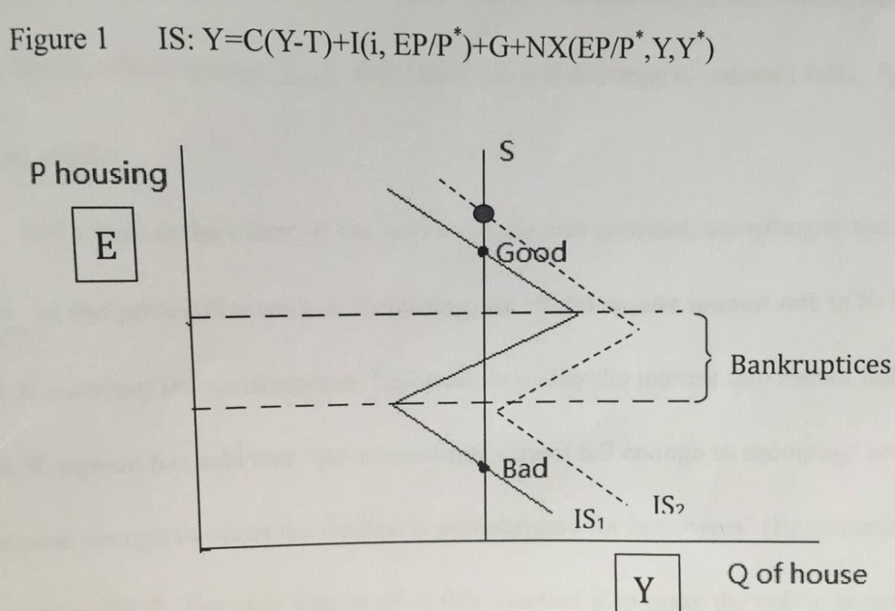

Since the global financial crisis, the china’s debt burden has increased. According to a recent report from the management consulting firm McKinsey & Company, China’s total debt in 2007, counting that of private households, independent firms, and government institutions, equaled 158 percent of the country’s GDP. In 2014, it reached 282 percent of GDP—among the world’s highest levels for a major economy. (Chen, 2015) The main reason is that the government has made loans to buy a large amount lands in order to stimulate the economy. The statement which is that investment drive the economic growth is correct in some extent, and it is also the advantage of the China’s economic system. Actually, the booming real estate market has driven the Chineseeconomic success. Also the rising property price provided the basis for a massive expansion of credit. (Chen, 2015) According to keeping the price of real estate high, the government has the ability to invest the infrastructure and industrial project so that avoid housing bubbles. Unfortunately, there is over supply in the real estate market. The government struggles in the recession of housing market, if the government sells land to one of its own entities, it amounts to self-dealing. The sale, in other words, is fake. (Chen, 2015) Finally, the result is that the property price is declining and the debt will accumulate.

1. Evidence.

Suffering the Minsky moments, Fed funs rate was too low in 2002-2006. During this period, it create a predictable environment for business. Low interest rate create bubble. The following part shows that how Taylor rule consistent the Ministry moment.

1.

John Taylor claims that Fed caused housing crisis by keeping Fed funds too low for to long. In fact, from Board of Governors of the federal reserve system ‘s research, as shown in diagrams below , that Fed funds rate is unusually low during 2002 and 2007. Especially the fed funds rate is nearly zero since the year of 2008.

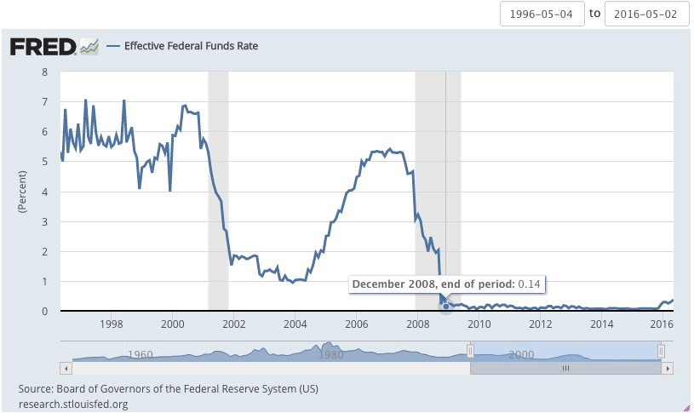

Whatever the timing, the US, China and Europe are all faced another Minsky moment: The point in debt inflation where the cash generated by assets is insufficient to service the debt taken on to acquire the asset. In this way the Fed incentives to keep interest rates low and create inflation so that they can pay off existing debt with cheaper dollars, avoiding insolvency.

In order to avoid the deflationary depression, the Fed has more than tripled the money supply since 2008 in an attempt to spur price inflation. However this money is not moving around in the economy and has not bid up the price of goods as much as intended.

After talking about the decreasing Fed Funds rate during financial crisis, the housing market also faced a huge challenge after crisis. According to the research of Real Resident Property Prices for United States,United Kingdom and Canada. From the graph we can easily see that there is an obvious downside tendency after 2007 the financial Crisis. We can explain this low house pricing phenomenon by Minsky

story.

2.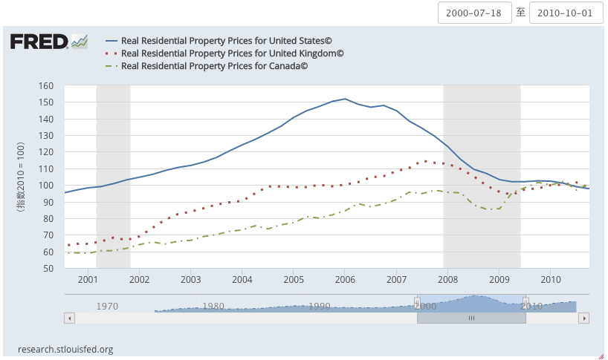

The decreasing price of house force people to sell house. Bank incentives people to sell their house and use that money to pay back the debt. But People are worried no paid back as the price of house decreasing. So people incentives not to sell the house to pay their debt. Then the price of housing would still decrease and maintain in low stage.

Debt and financial fragility theory suggests that financial crises follow a credit cycle with an initial positive shock (displacement) provoking rising debt, mispricing of risk by lenders and an asset bubble ,which is punctured by a negative shock, leading to a banking crisis. These patterns are seen as a normal feature of the business cycle (Fisher, 1933; Kindelberger, 1978; Minsky, 1977).

With the decreasing housing prices, the government faced a huge challenge. How does the government plan and predict the future price?

VAR data does not show Fed funds effect housing start during 1985-2007 which is inconsistent. Let us show you how does it happen in VAR model.

3. VAR in INF HISTART UR FF

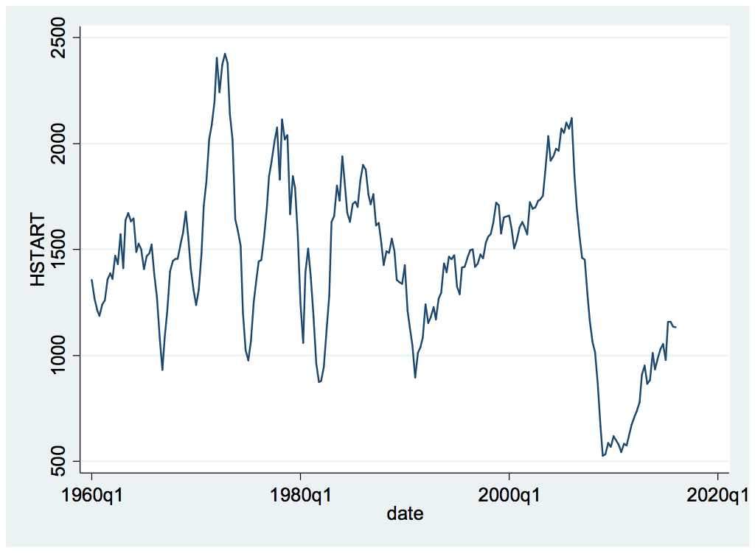

In this graph, it seems to me that focusing on small increase in a few years is misleading. The tendency of this line from nearly 1990-2007 is increasing. Taylor says Fed Funds is too low during 2002-2006. But trend increase housing starts which begins in 1990 . It exists a small peak at the year of 2007 . Then comes into a big shut down. Trend way back 1990’s ,which is established much earlier than the deviation.

1965-1985

VAR in INF HSTART UR FF (HSTART) is housing starts.

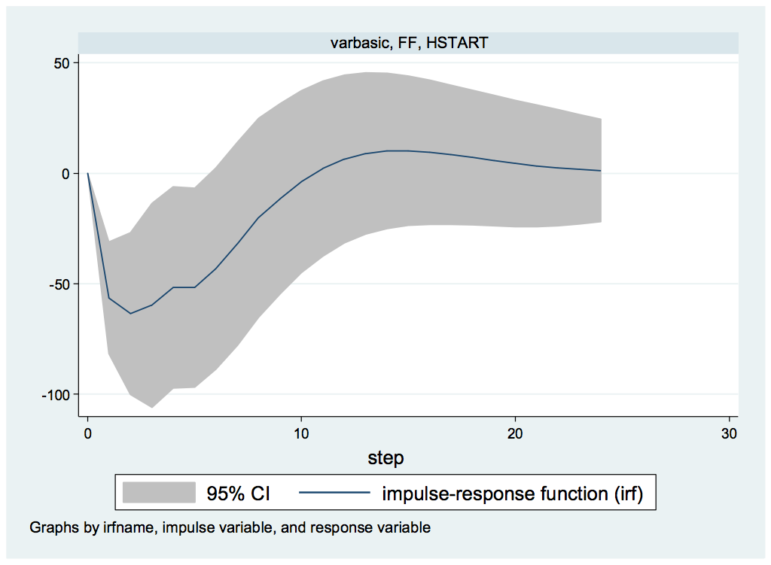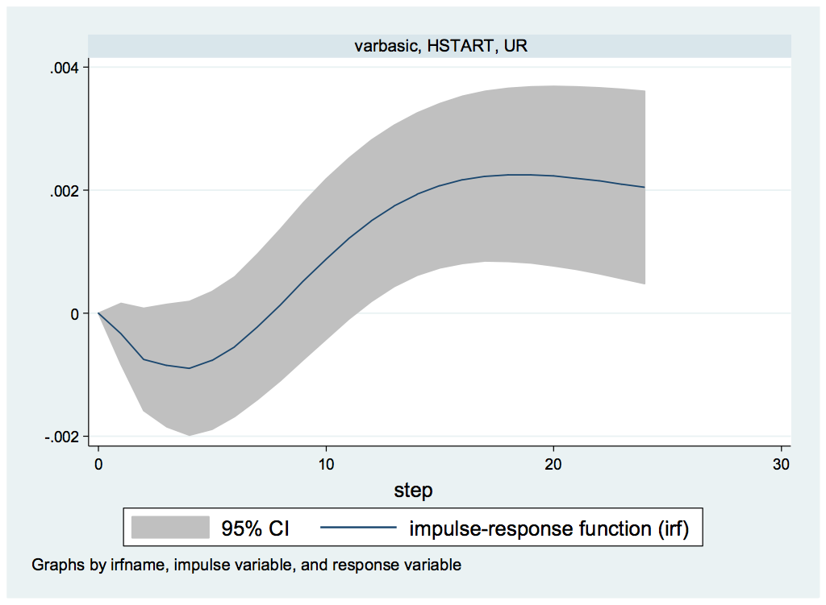

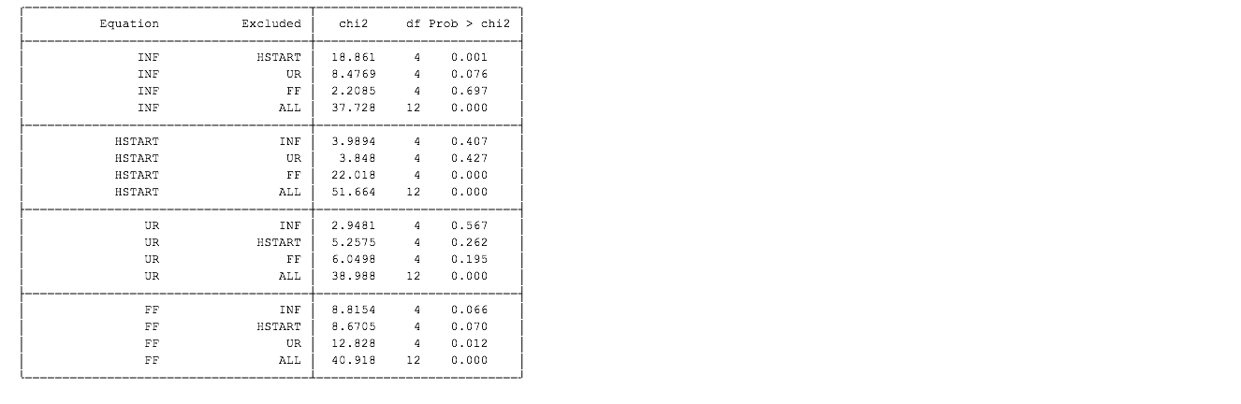

In the left side, the VAR FF,HSTART graph means that higher FF reduces housing starts. In the right side, the VAR HSTART, UR graph means that housing starts exactly affect UR. From these VAR graph in 1960-1985, the situation consistent with Taylor’s rule.

1985 2007

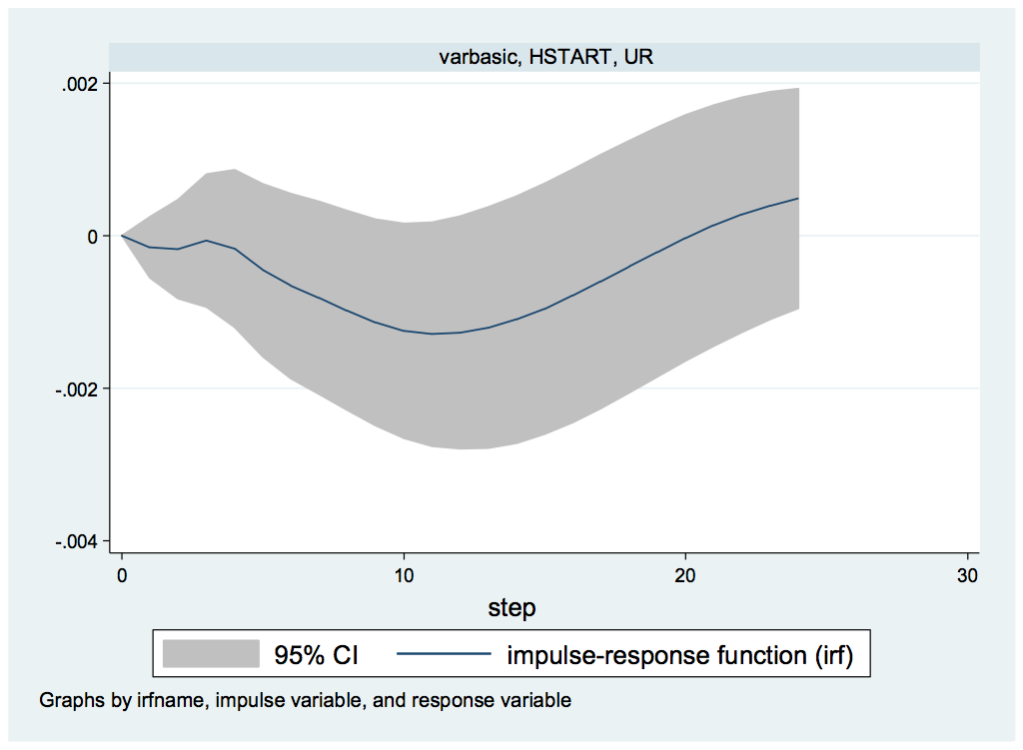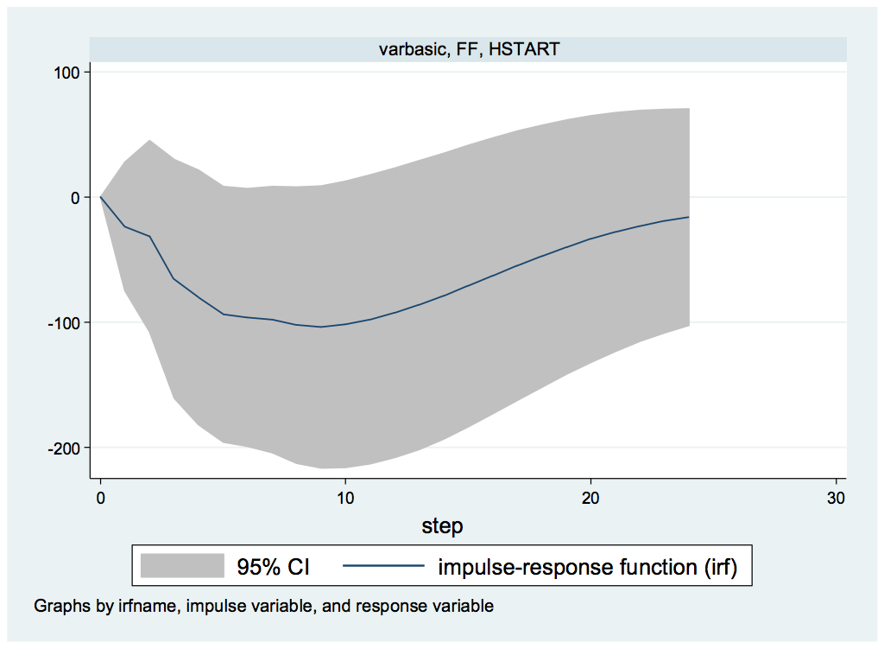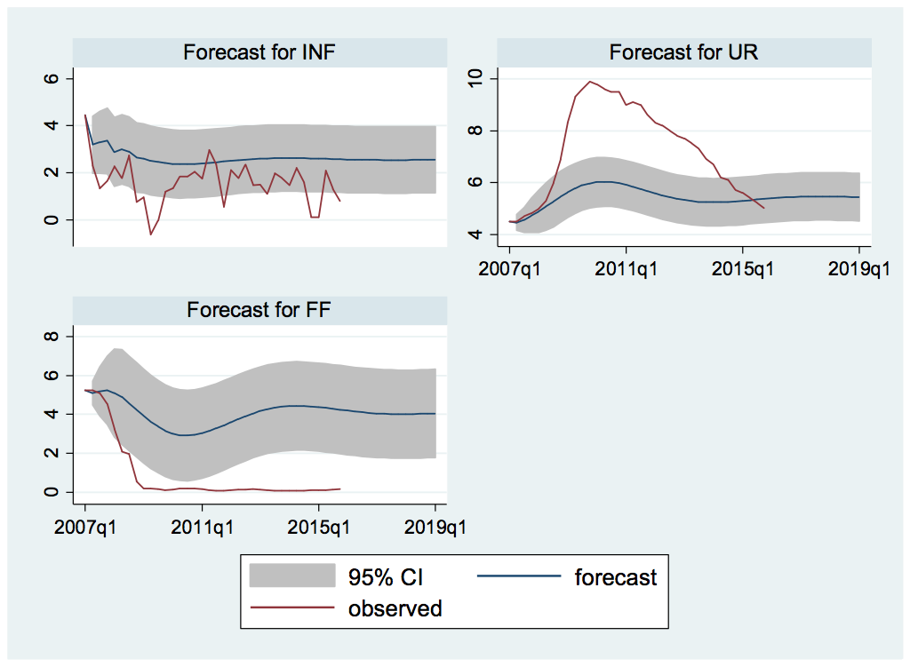

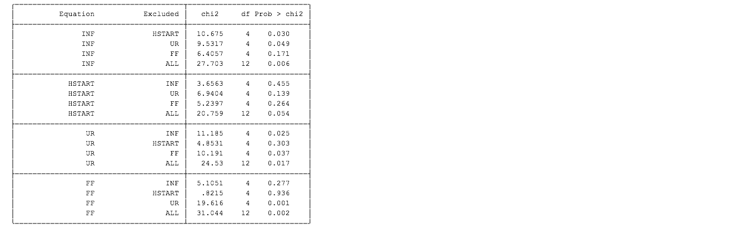

As shown in 1985-2007 VAR graph, there is a big change behavior after 1985. From the table , we can read that the HSTART and FF line, The df probability>chi2 is 0.264. Which means it reject the rule. So that the government lose control of housing prices. They lack of plans, also lack of control. So there is no consistant plan be obtainded. People can not blame Fed because they already lose controllment. The behavior of government after 2007 is difficult to predict since the change is so fast, we still do not know thet tendency it will be.

With low interest create bubble and Fed lose controllment and predictable plan happened , China also faced similar debt problems and suffering the Minskey moments.

4.

Blinder obtained that the Minsky moment followed by inter locking debt. According to the latest post about China, which is looking a whole lot like an overleveraged economy at great risk of a Minsky moment.

In the middle years of the last decade, China was able to sustain growth despite weak consumer spending thanks to massive and growing trade surpluses. But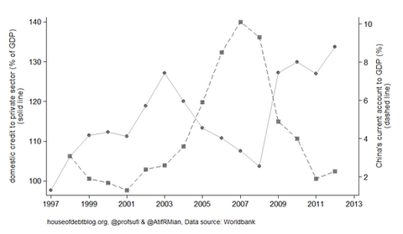 as the surplus eroded, it turned to sustaining extremely high and probably low-return investment via credit expansion — and now debt levels are looking scary.

The very truth of debt is that it is an overdraft of credit. A credit default may occur if future cash flow of a debtor is not sufficient to service the principle and interest. When a significant portion of debtors’ future cash flows are far short of paying the interest, the scale of debts will escalate, resulting in a occurrence of Minsky Moment. The world economic history tells that agents will be very greedy and desperately raise their debts by raising leverage ratio in a long booming period, which imbeds causes of financial crisis and subsequent bitterness of enduring developing process. The recent US subprime debt crisis and European sovereign debt woes have reiterated this fact. Nowadays business community, policy makers and academic researchers worldwide are very wary about a possible widespread default of local government debts and consequent home-made financial crisis in China.

Stories from 2008 crisis, Leham,Bear ’s MMF’s may be similar to future events in clinic. For example: Queen of spades problem

5.

Defination— Lack of trust as people dump the bad debt on unsuspecting buyer. The changing behavior about who is not increasing uncertainty.

The equity market, which had been surprisingly little affected by the crisis up to that point then began to fall sharply. This particularly reflected low confidence in banks that were dependent on wholesale funding. Since markets for such funds, that had previously been costly and restrictive, proved to be totally closed to such institutions after Lehman’s failure. Cross border lending was even more sharply curtailed than domestic, showing again the historic instability of the international interbank market (Bernard and Bisignano, 2000). Money market funds in particular underwent losses when Lehman’s collapsed, and this led to them ‘breaking the dollar’ .needing support from the Federal Reserve. They underwent massive redemptions ($320 billion in one week), as did hedge funds and mutual funds, leading to forced asset sales which intensified the downward spiral in asset prices. Instead of offering liquid funds to banks, money market funds began rather to compete with them for financing. The Fed had to start purchasing commercial paper directly from non-financial companies to avoid a liquidity crunch for them. A large number of creditors, including significant hedge funds, had their assets frozen in the Lehman bankruptcy, and were forced to find alternative funds, adding to selling pressure in equity markets.

1. Policy: Krugman VS Taylor Vs Blinder

Krugman claims that Housing bubble which is not gov. In Krugman’s theory in 2008, debt accomplices. But some points creditors decide they have lent too much. It will force borrowers to sell assets to repay. Government solves the debt crisis with more debt.

Taylor rule is about Fed policy. Which is controlled by government. He obtained that Fed Funds should equals to

β0(inflation - desired inflation)+ β1(unemployment- desired unemployment)

β0>0 , β1<0, known that it was constant, so investors can plan in order to maintain policy stability .Deviation lrm rule create uncertainty. Claims that 2004-2007 Fed funds is less than Taylor rule rate. Which encouraged housing bubble and helped create crisis.

Blinder 2008 is about Bear Sterns and Lehman Brother. Government lets stock holders of both lose but bail out Bear’s Cenler But not Lehmans. Lehman Brothers closed Sep 15,2008. Other invest meant banks worry they are need increase cloakroom demands on AIG. AIG holds CDs guaranteeing CDO’S.

1. Conclusion

This article mainly talk about the Minsky moment which happens in2002 and 2007. We introduce the Minsky moment which is a long quiet period of no crisis leads to leveraging to increase yields as willingness to take risk rises, and also we introduce and analyze the Krugman theory which include the IS-LM model and multiple equilibrium. We also mentions that basic idea applies to china is that local government debt secured by housing prices. The article list five evidences happened during the Minsky Moment. Taylor’s rule mentioned the result in financial crisis- which is the Fed makes the fed funds rate stays low and happened inflation. In addition, the housing pricing stays low stage after the crisis and form a stable cycle. The locking debt is become a severe problem suffered by China. Therefore the bank happened lacking of trust risk. At the forth part of the policy part, this article mentioned three symbolic economists- Krugman, Tayler, and Blinder. These three economists theory has their advantages and abuses. However, due to the analysis of the Minsky moments, we feel the huge influences from the financial crisis happened in 2002 and 2007.

Citation

Chen, Z. (2015). China’s Dangerous Debt. *Foreign Affairs*, 94(3), 13-18.

Cassidy, J. (2008). *Subprime mortgage crisis and possible recession - The New Yorker*. *The New Yorker*. Retrieved 6 May 2016, from <http://www.newyorker.com/magazine/2008/02/04/the-minsky-moment>

Cassidy, J. (2015). *China’s Long Minsky Moment - The New Yorker*. *The New Yorker*. Retrieved 6 May 2016, from <http://www.newyorker.com/news/john-cassidy/chinas-long-minsky-moment>

Komlik, O. (2015). *China’s Minsky moment: stability leads to instability*. *Economic Sociology and Political Economy*. Retrieved 6 May 2016, from <https://economicsociology.org/2015/08/24/chinas-minsky-moment-stability-leads-to-instability/>

Barrell, R. & Davis, E. (2016). *THE EVOLUTION OF THE FINANCIAL CRISIS OF 2007–8* (1st ed.). Retrieved from <https://www.brunel.ac.uk/__data/assets/pdf_file/0015/82212/davisbarrellevolutionpaper.pdf>

Stockman, D. (2014). *The Minsky Moment Cometh: Extend And Pretend Nears Its End*. *David Stockman's Contra Corner*. Retrieved 6 May 2016, from <http://davidstockmanscontracorner.com/the-minsky-momemt-cometh-extend-and-pretend-nears-its-end/>

Zhang, F. (2015). *China’s Minsky Moment*. *Global Perceptive*. Retrieved 6 May 2016, from <https://globalperceptive.com/2015/09/12/201/>

Popik, B. (2016). *The Big Apple: Minsky Moment (Minsky Crisis)*. *Barrypopik.com*. Retrieved 6 May 2016, from <http://www.barrypopik.com/index.php/new_york_city/entry/minsky_moment>

Goltermann, J. (2016). *Surviving Our Minsky Moment | Monthly Commentary | Obermeyer Wood Investment Counsel*. *Obermeyerwood.com*. Retrieved 6 May 2016, from <http://www.obermeyerwood.com/site/article/surviving-our-minsky-moment/>

Kientz, R. (2016). *Minsky Moment For The U.S. - Perpetual Dollar Printing Is Inevitable*. *Seekingalpha.com*. Retrieved 6 May 2016, from <http://seekingalpha.com/article/704881-minsky-moment-for-the-u-s-perpetual-dollar-printing-is-inevitable>

Krugman, P. (2016). *Chinese Debt Worries*. *Paul Krugman Blog*. Retrieved 6 May 2016, from <http://krugman.blogs.nytimes.com/2014/03/14/chinese-debt-worries/?_r=0>

Board of Governors of the Federal Reserve System (US), Effective Federal Funds Rate [DFF], retrieved from FRED, Federal Reserve Bank of St. Louis <https://research.stlouisfed.org/fred2/series/DFF> , May 3, 2016.

Bank for International Settlements, Real Residential Property Prices for United States© [QUSR628BIS], retrieved from FRED, Federal Reserve Bank of St. Louis <https://research.stlouisfed.org/fred2/series/QUSR628BIS> , May 3, 2016.

Bank for International Settlements, Real Residential Property Prices for United Kingdom© [QGBR628BIS], retrieved from FRED, Federal Reserve Bank of St. Louis <https://research.stlouisfed.org/fred2/series/QGBR628BIS> , May 3, 2016.

Bank for International Settlements, Real Residential Property Prices for Canada© [QCAR628BIS], retrieved from FRED, Federal Reserve Bank of St. Louis <https://research.stlouisfed.org/fred2/series/QCAR628BIS> , May 3, 2016.